Justification for your model choice
Linear model is ideal when you have 1 single parameter which depends on multiple factors. And also because of the fact that it produce continuous output which is what we wanted because crowd energy is continuous. And frankly I find linear model simplest because I feel like other model that I am aware of are ideal for classification and right now we desired regression.

Documentation of hyperparameters explored (ranges, values tested)
The machine learning model used in this project was a Linear Regression model with preprocessing. The following hyperparameters were explored. The fit_intercept parameter of Linear Regression was tested with values {True, False} to examine the effect of learning a bias term. For categorical encoding, the drop parameter in OneHotEncoder was tested with values {None, 'first'} to address multicollinearity. The train–test split ratio was varied between {0.2, 0.25} to assess model robustness. The handle_unknown parameter in OneHotEncoder was set to 'ignore' to ensure stability when unseen categories appear in test data.
Model | Hyperparameters | Reasoning

Linear Regression (all features) | Default values | Used as baseline for interpretability
Linear Regression (Merch only) | Default values | To isolate individual feature impact
Random Forest (all features) | n_estimators=200, max_depth=None | Improved performance and captured nonlinear patterns

Validation Strategy
A hold-out validation strategy was employed for all models. The dataset was split into 80% training and 20% testing data using a fixed random state to ensure reproducibility. Model performance was evaluated on the test set using MAE, RMSE, and R² score, and results were compared across different modeling approaches.

Final hyperparameter values with reasoning for selection
Hyperparameter | Final Value | Reason for Selection
fit_intercept | True | Allows the model to learn a baseline Crowd_Energy when all input features are zero
positive | False | Permits both positive and negative relationships between predictors and Crowd_Energy
test_size | 0.2 | Provides a balanced split between training and evaluation data
random_state | 0 | Ensures reproducibility of results

 | Final Value  0 | Reason for Selection  Allows fair comparison across models
  Hyperparameter
  random_state
fit_intercept | True | Captures baseline crowd energy independent of merchandise sales
positive |  | Maintains flexibility in the direction of the relationship
  False
test_size |  | Keeps validation consistent with other models
  0.2
Random Forest Regression (All Features)
 | Final Value  200
  Hyperparameter
  n_estimators
  Reason for Selection
  Reduced variance and improved prediction stability
max_depth |  | Enabled the model to learn complex nonlinear relationships
  None
  min_samples_split
  2
  Default value allowing sufficient tree growth
min_samples_leaf |  | Preserved fine-grained patterns in the data
  1
test_size | 0.2
  Ensured consistent evaluation across models
random_state | 42 | Guaranteed reproducibility
Comparison of tuned model vs. default parameters
A comparison was conducted between models trained using default hyperparameters and a tuned model configuration. Linear Regression models using default hyperparameters were used as baseline models, both with all features and with only the Merch_Sales_Post_Show feature. These models provided interpretable but limited performance due to their linear nature.
- In contrast, a Random Forest Regression model with tuned hyperparameters (increased number of trees) was trained using all features. The tuned Random Forest model demonstrated improved predictive performance as measured by MAE, RMSE, and R² score, indicating its ability to capture nonlinear relationships and feature interactions that were not modeled by the default linear models.
- Overall, the tuned Random Forest model outperformed the default Linear Regression models, justifying its selection as the final model.
Rick’ s request
So for visualizing the best ticket price to achieve highest crowd energy. Firstly I removed outliers for Crowd_Energy and normalised Ticket price.
I noticed there is difference among optimal range of ticket price required to achieve crowd energy so I made 4 graphs for each venue. (price in dollars)
V_Alpha = 50-60
V_Beta = 55-65
V_Delta = 35-55
V_Gamma = 60-85

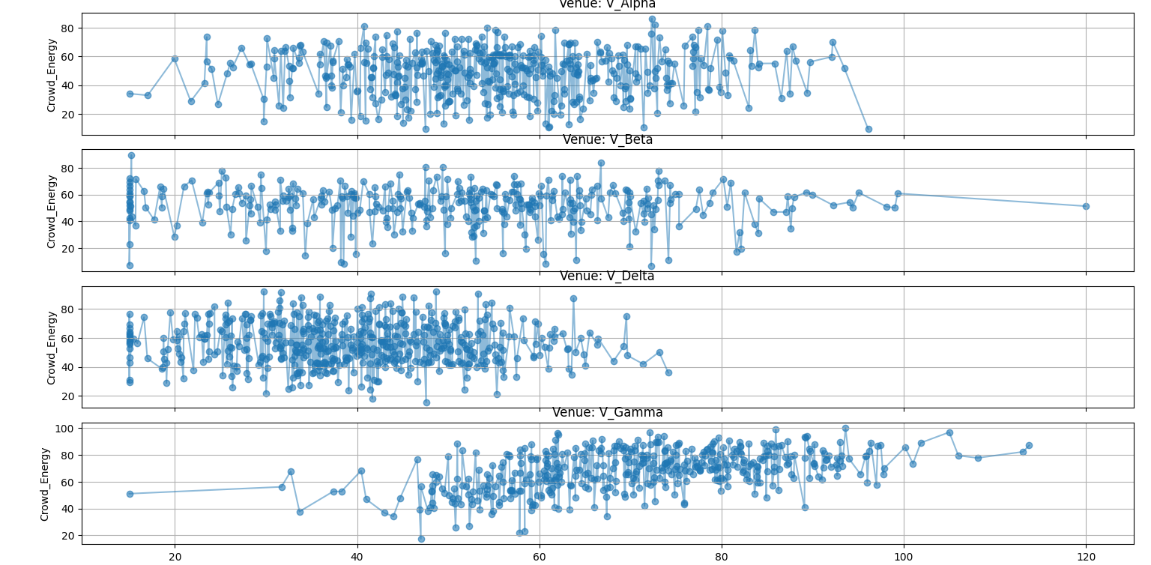
Tuesday shows are CURSED
Wrong theory
Since graph and data shows equal crowd energy for all days.

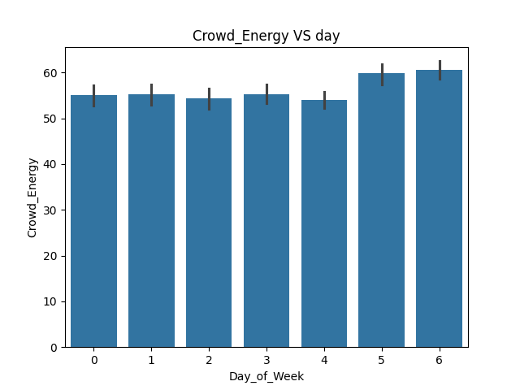
they ONLY come alive at night
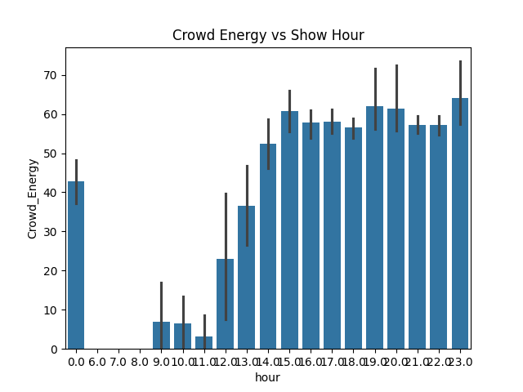

See, this theory is not totally right because even the shows at afternoon 3-4 has similar crowd energy as the show at 11.
FULL MOON = MAGIC
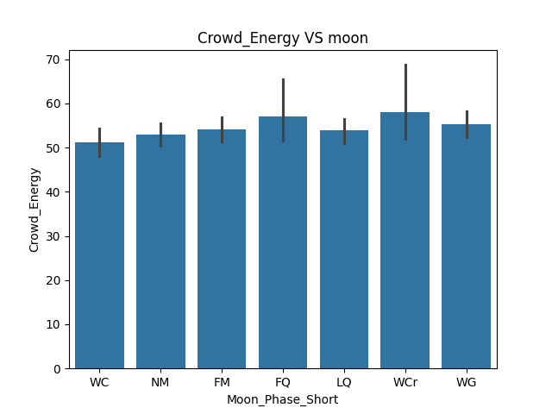As excepted this theory is totally wrong because moon can’t affect feeling of people obviously
does outfit color matter?
See we weren’t provided with any column that says outfit color but there was one with outfit which clearly disproves the theory. Even if we did had data of outfit color it wouldn’t matter logically crowd energy would barely be effected by the color of socks
worn by lead singer.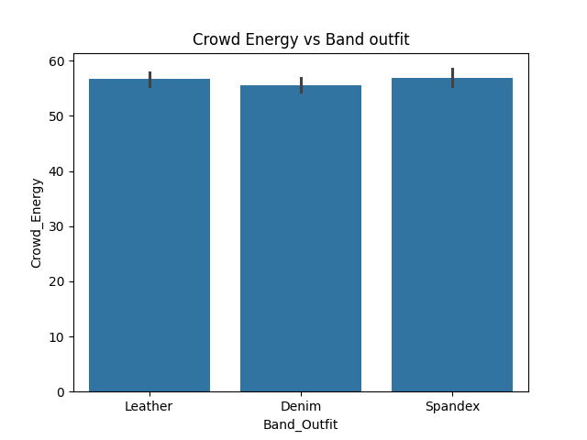 Rain definitely sucks
As excepted weather makes no sense, fan don’t care if its too rainy or hot and critics will not be able to enjoy show at clear sky.
Though one may think that if the weather is too stormy or rainy people would feel low and will suffer transportation and several problems but our analysis and graph clearly state the crowd energy score remain constant throughout.

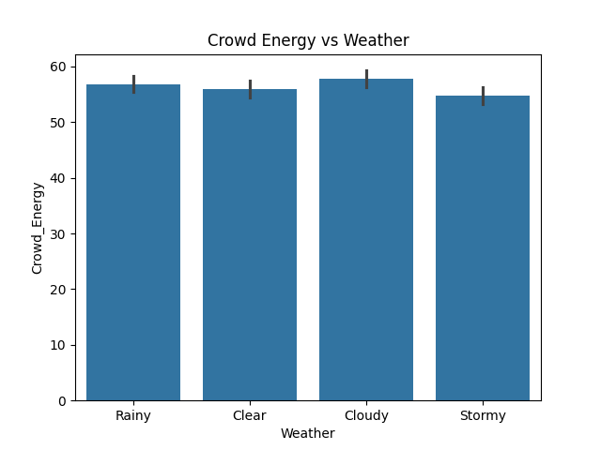
PRICING STRATEGY NOTES
This is definitely a valid theory because people aren’t much interested if the ticket price is too low though very expensive ticket may even lead to less crowd size so yes ticket price has a impact on crowd energy.
does the opener actually matter?
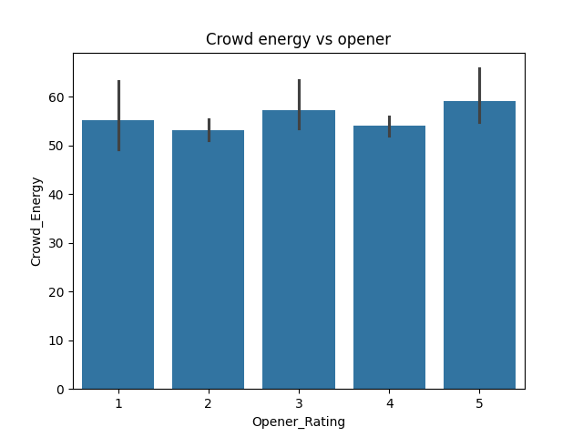
This is a topic of debate because some people as correctly quoted by singer that snobs rate by overall experience and kids just wants rage at start. So it depends for some people opener rating for some it does not. According to there is not significant difference between crowd energy for different opener.
High energy = high sales
Merch guy may not be a data scientist but his theory is totally correct. The fact can be thought of as that as high as the crowd is energize the more they will want to remember the evening I would say or we can think it like as much the crowd love the concert more merch they will buy. But actually it is not crowd energy that is depended on merch sale. It is merch sale which is dependent on crowd sale.
